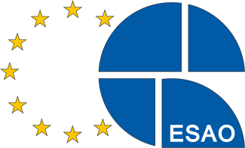

**European Society**

**for Artificial Organs**

# Announcement

# ESAO–SAGE–Research AWARD 2025

The annual ESAO-SAGE-Research Award 2025 of € 2,500.00 is aimed at encouraging young scientists working in the fields of medical sciences, biomedical engineering, biology, biochemistry, chemistry, physical chemistry, material and membrane sciences, as well as chemical engineering related to the general field of artificial organs with particular emphasis on

1. New developments in artificial organs, tissue engineering & regenerative medicine,
2. Implementation of artificial and bioartificial organs in clinical practice, OR
3. Improvement of clinical application strategies.

The awardees will be selected by a committee appointed by the ESAO Board of Governors.

Applicants, who must be members of the European Society for Artificial Organs, should submit one original manuscript (with the applicant as the **first author**), together with **one blinded version** to be used in the anonymous peer-review process. Please send both electronic files (pdf format) to [anita.aichinger@donau-uni.ac.at](mailto:anita.aichinger@donau-uni.ac.at). The manuscript has to fulfill one of the following conditions:

1. Published after January 1, 2024 in the International Journal of Artificial Organs, OR
2. Accepted in the International Journal of Artificial Organs for publication at the time of application (include a letter of acceptance).

A current curriculum vitae (including date of birth) with a bibliography of the candidate's work should also be submitted. The applicant has to be under the age of 38 at the time of submission.

Applications should be submitted electronically before **April 30, 2025.**

Prof. Dr. Dimitrios Stamatialis

ESAO President Elect

Contact:

Prof. Dr. Dimitrios Stamatialis

Advanced Organ bioengineering and

Therapeutics-Technical Medical Centre

Faculty of Science and Technology

University of Twente

P.O Box 217

7500 AE Enschede

The Netherlands

d.stamatialis@utwente.nl

*SAGE-logo-SVG.pngSponsored by: SAGE Publishing*